St Paul’s Church, Craig y Don
presents
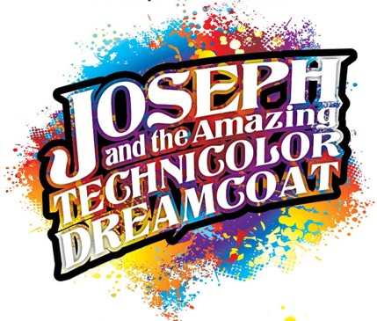
This summer holiday workshop for 7-12 year olds will be held at St Paul’s Church in Craig y Don, Llandudno from 19th to 23rd August 2019, 9am until 3pm on each day.
Participants will work throughout the week towards a performance of the work on Friday 23rd at 4pm in St Paul’s.
Come and join the fun!
Cost £10 per child for the week or FREE IF YOU BOOK BY 1st JULY!
In addition to singing, dance and drama, activities will include arts & crafts & scenery-making, as we prepare for the performance.
Fully supervised. All adults hold DBS certificates
Drinks & snacks provided but please bring a packed lunch.
More details: Rev Ginny Burton
01492 642778
or e-mail:
family@stpaulsllandudno.co.uk

If you would like to join us,
please complete this registration form and return by Friday 19 July to the email address above, or to:
Reverend Ginny Burton
Parish Office
Penrhyn Beach East
Penrhyn Bay
LL30 3NT

Registration Form

TO BE RETURNED BY FRIDAY 19th JULY LATEST!

Full name: ...........................................
Age: ........ Date of birth: .................
Address: .............................................
...............................................................
Postcode: ............................................
Emergency contact name & no:
- ........................................................
........................................................
- .........................................................
.........................................................
Allergies &/or medical conditions:
............................................................
............................................................
P.T.O.
Dietary needs:
..................................................................
Any other information you feel we ought to be aware of:
..................................................................
I consent for ......................................
to attend the Joseph holiday workshop from 19th to 23rd August 2019 Signature of parent/guardian:

.................................................................
Photo Permission
We would like to include photos taken during the week on the parish and diocesan website and newsletter. If you are happy for us to use photos of your child, please sign below. If this is a problem, please contact us and we will ensure that any photos including your child are not published anywhere.

Signature: ................................

Privacy Statement

We will keep the information on this form strictly confidential and use it only in the organisation of this event. You can ask us to stop contacting you at any time – get in touch via the addresses on this form.

by Tim Rice & Andrew Lloyd-Webber

Your place on the workshop will be confirmed by Monday 29th July
We look forward to seeing you!

Deborah Haigh Roberts
Director of Music
St Paul’s Church

Reverend Ginny Burton
Family and Community Officer
St Paul’s Church

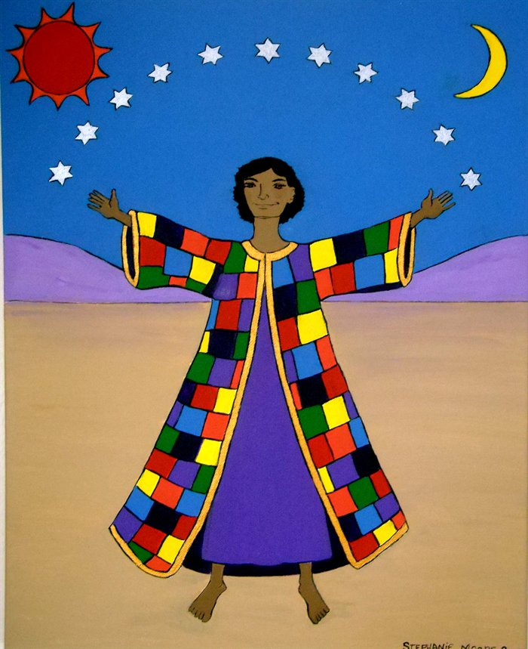

In A Week!

19th - 23rd August
St. Paul’s Church
Craig y Don

